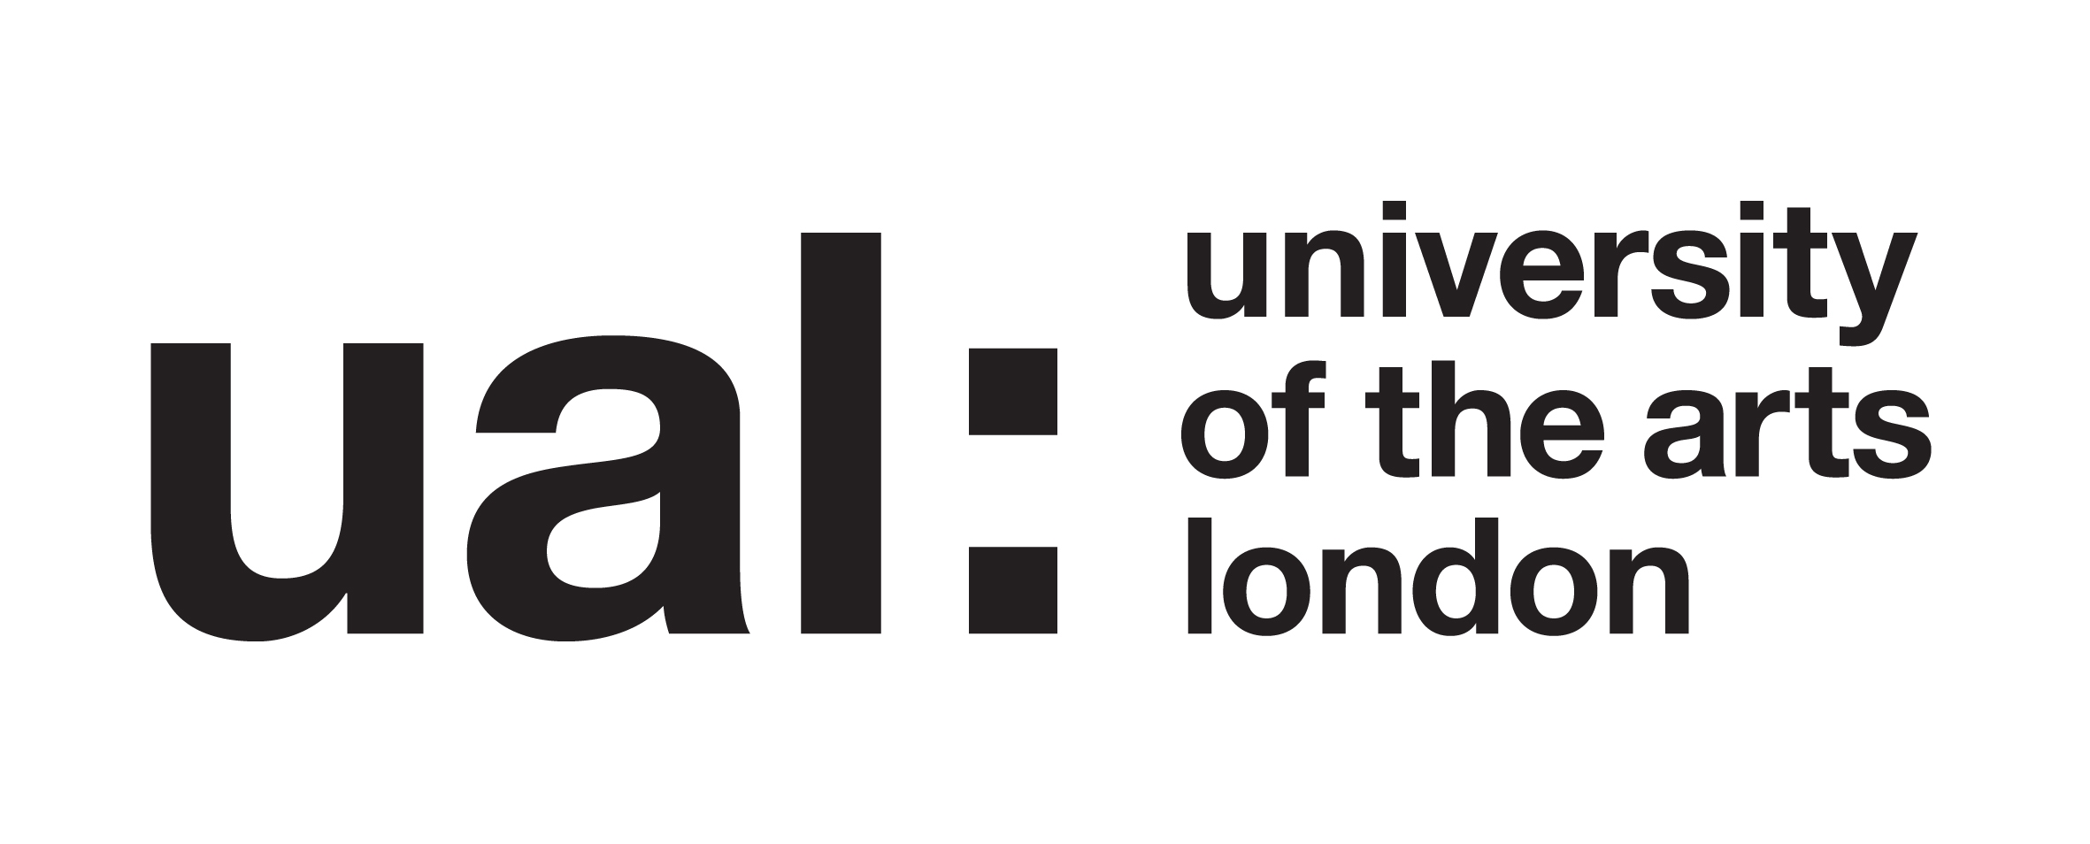

Research project: Identifying barriers: What are the contributing factors on the BA and MA costume courses that prevent students with physical disabilities/mobility impairments from applying or succeeding on the course?

Participant Information Sheet

About this study

This study is part of my research on the PgCert Academic Practice in Art, Design and Communication at UAL.

I am conducting research using mixed methods consisting of room observation, interviews and secondary research in order to help answer my question.

My research will look to see what barriers we have on the BA and MA costume courses in hopes to remove them. The methodology will be qualitative and quantitative focusing on comparative and thematic analysis.

What does it mean to take part?

If you take part you are consenting to taking part in either an interview or feedback forms. You may also be asked to take part for other reason such as being asked for advice for practical parts of the project. The data will be used as the basis for academic analysis.

If you choose to take part, you will be free to withdraw your participation at any point. You will not be obliged to give any reason for deciding not to take part.

Will my participation be kept confidential?

Your anonymity is very important. The information about you will be confidential to me, as the researcher. You will not be identified individually anywhere in the research. If I quote anything you have said in an interview, it will be anonymous. An example might be: ‘Tutor A said ‘The project is…’.’

What will happen to the results of the research project?

Analysis from the Interviews and feedback forms - including quotations from you – will contribute to an academic dissertation. Your words may also be used in academic reports, papers or conference presentations [add anything else that you know you may do]. These may appear online.

Thank you for your contribution and participation in this study.

Contact for further information:
Sarah Masters, Investigator
s.masters@arts.ac.uk

