Photos

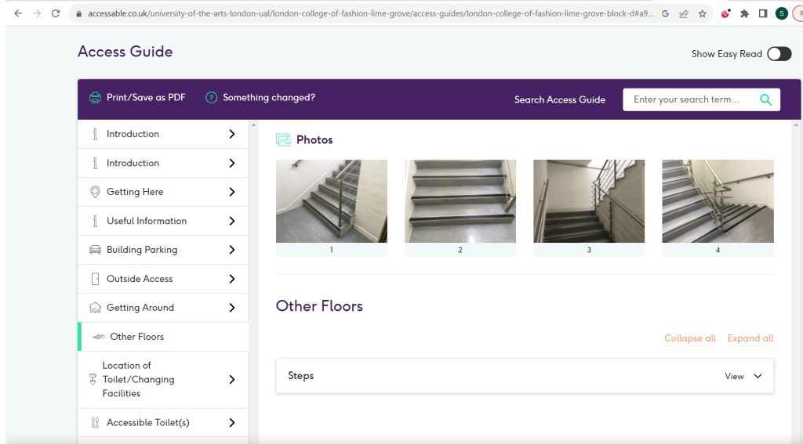

AccessAble (2023) London college of fashion - lime grove - block D. Available at: [https://www.accessable.co.uk/university-of-the-arts-london-ual/london-college-of-fashion-lime-grove/access-guides/london-college-of-fashion-lime-grove-block-d Accessed 17th November 2023](https://www.accessable.co.uk/university-of-the-arts-london-ual/london-college-of-fashion-lime-grove/access-guides/london-college-of-fashion-lime-grove-block-d%20Accessed%2017th%20November%202023)

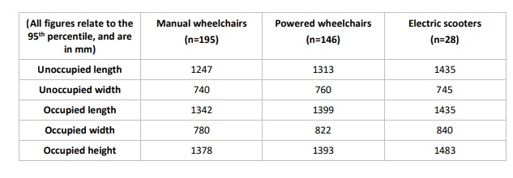

Barham, P. Greenshields, S. Mitchell, J. Average dimensions (2020) Barham, P. Greenshields, S. Mitchell, J. (2020) CLIENT PROJECT REPORT CPR2714 Accessible Public Realm: UpdatingGuidance and Further Research Technical Annex 2: A review of the dimensions of wheeled mobility aids (RQ2) Available at <https://assets.publishing.service.gov.uk/media/5e4d412986650c10e4580eb5/accessible-public-realm-annex-2-review-of-the-dimensions-of-wheeled-mobility-aids.pdf> Accessed 25th November 2023.

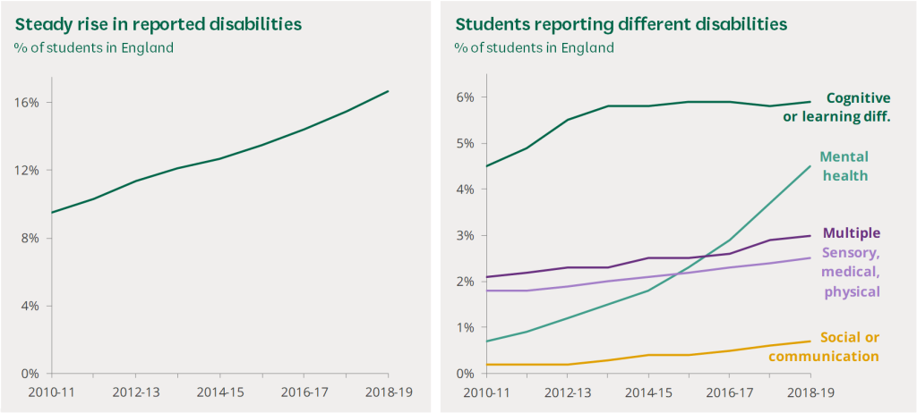

Bolton, P and Hubble, S. (2021) *Support for disabled students in higher education in England* p.g 7 Available at https://commonslibrary.parliament.uk/research-briefings/cbp-8716/ Accessed 25th November 2023

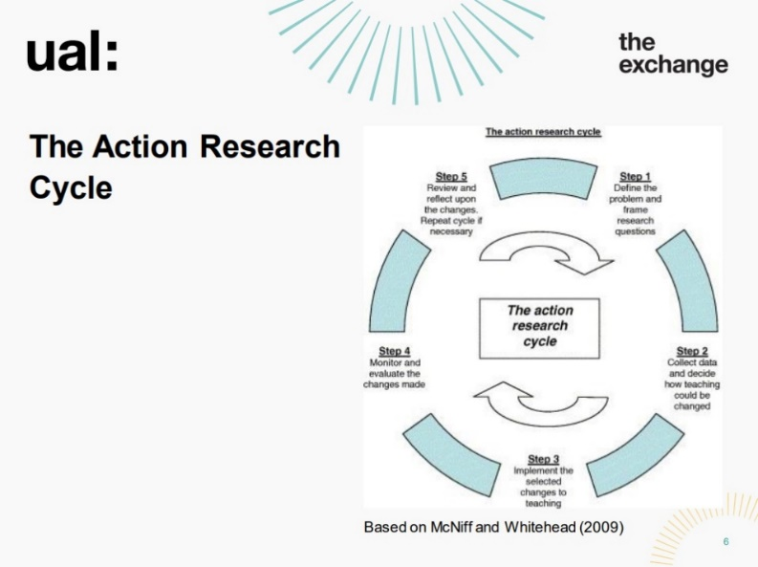

Marsden, R and Bunting, L. ARP Workshop 2 - week 23 October 2023 v.3. The Action Research cycle based on McNiff and Whitehead (2009) p.g 6 Available at https://moodle.arts.ac.uk/mod/folder/view.php?id=1118464 Accessed on 28th October 2023

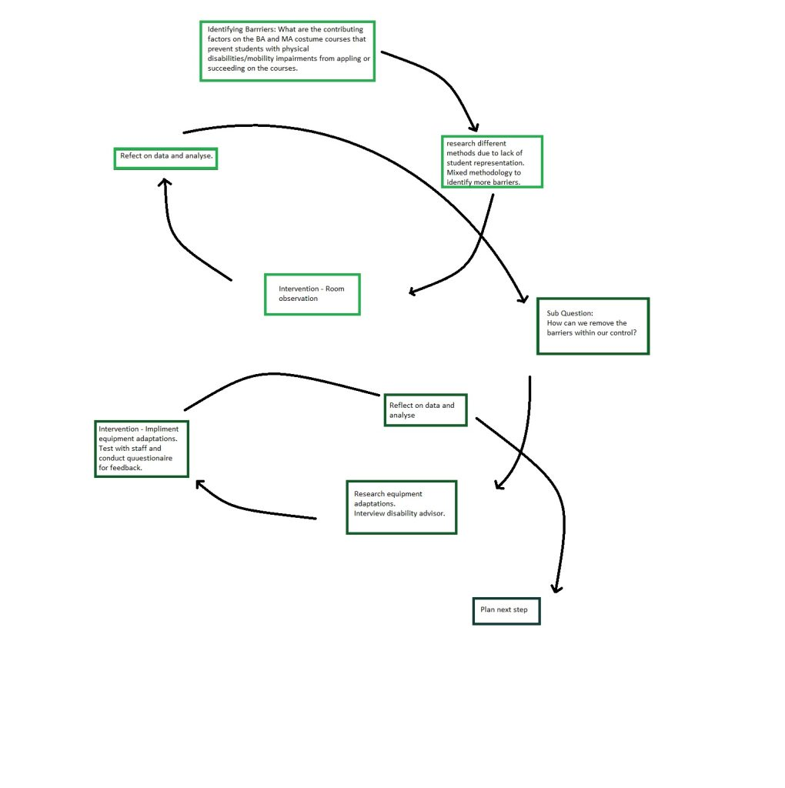

Masters, S. (2023) Action research second spiral.

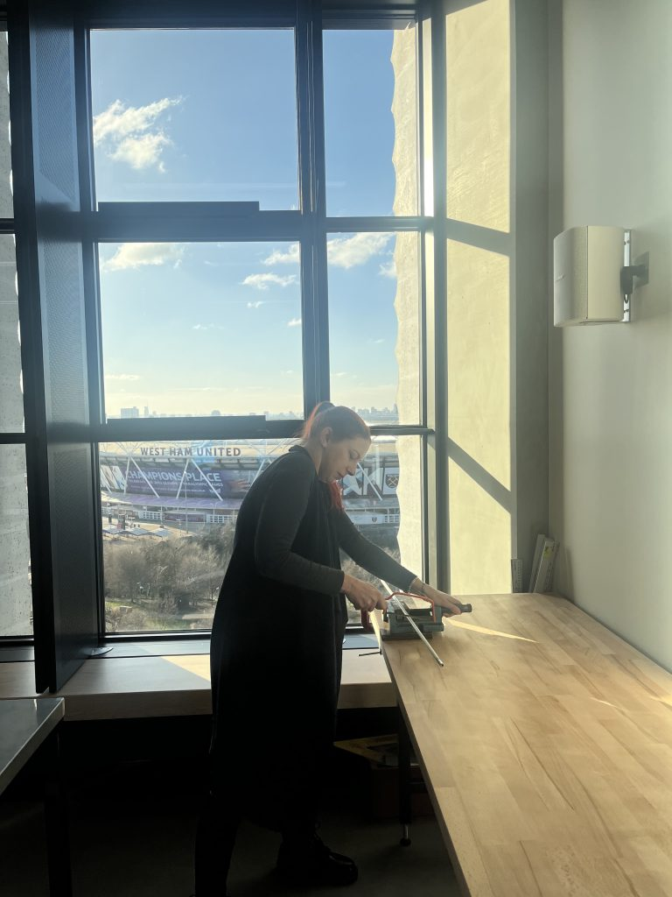

Masters, S (2024) Cutting the rod

Masters, S (2024) Do you feel that you could use this machine on a daily basis? Please explain in a few words why? Word cloud

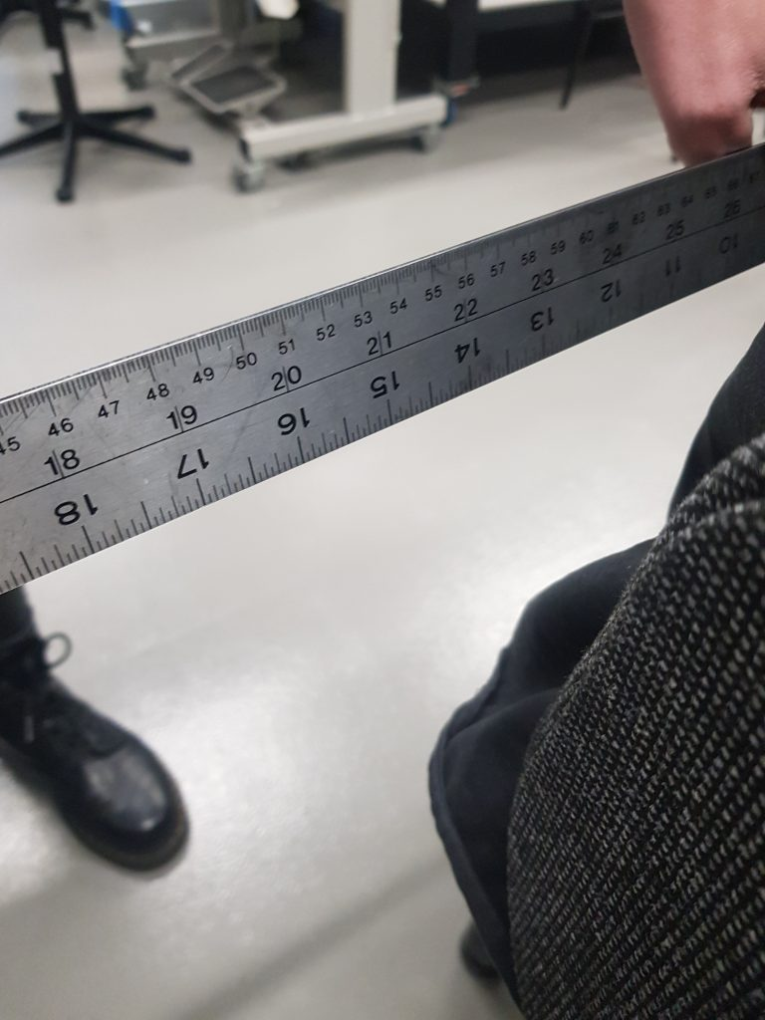

Masters, S. (2023) Distances between chairs

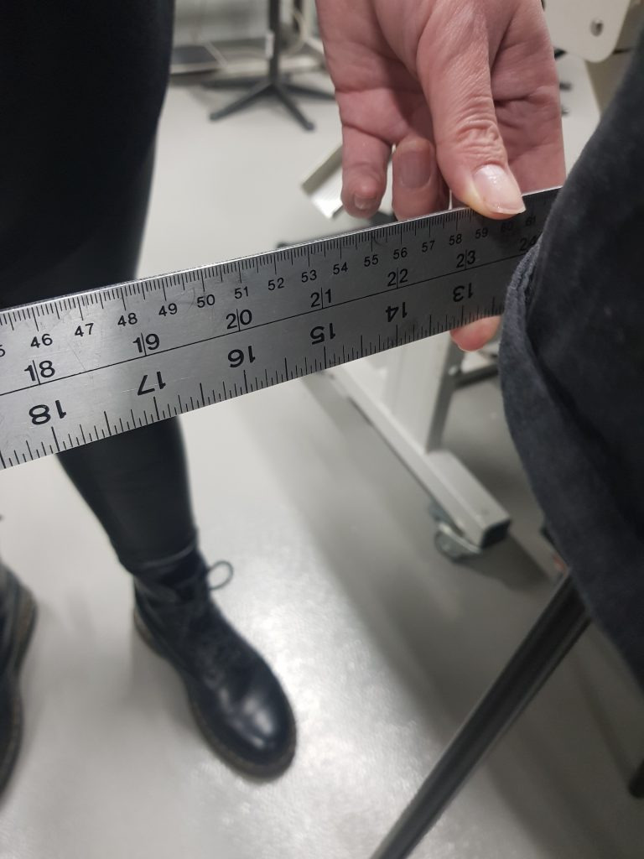

Masters, S. (2023) Distance between stalls

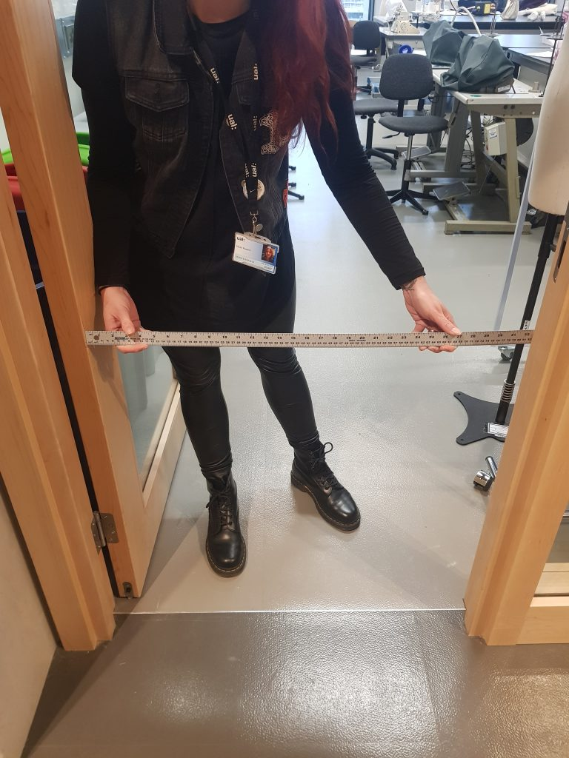

Masters, S. (2023)*Door to EB 823*

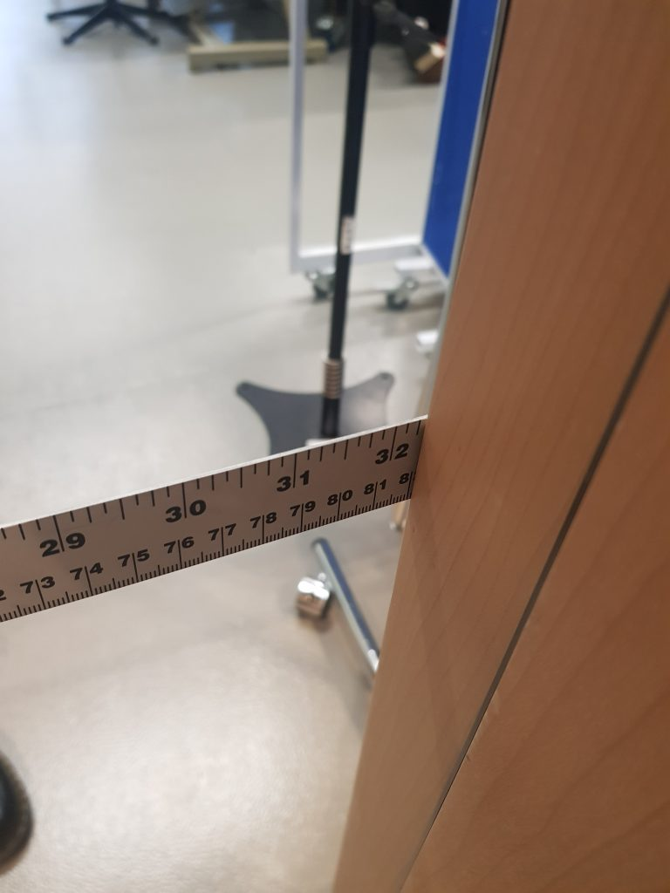

Masters, S. (2023) Door width

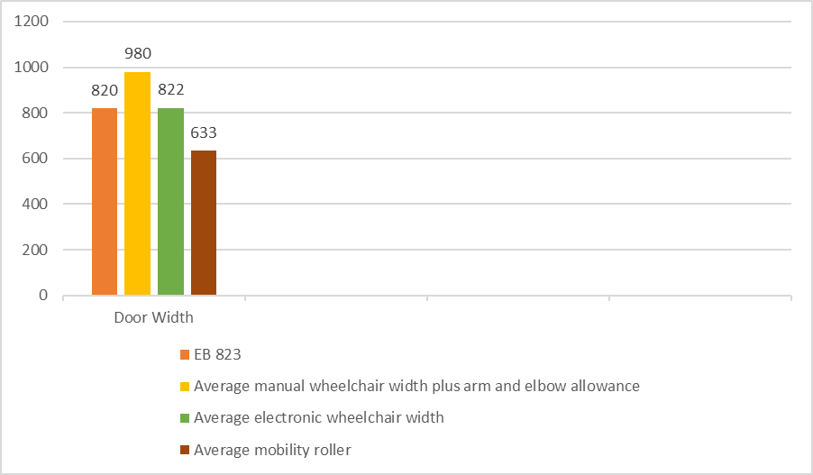

Masters, S (2023) *Door Width in EB 823*

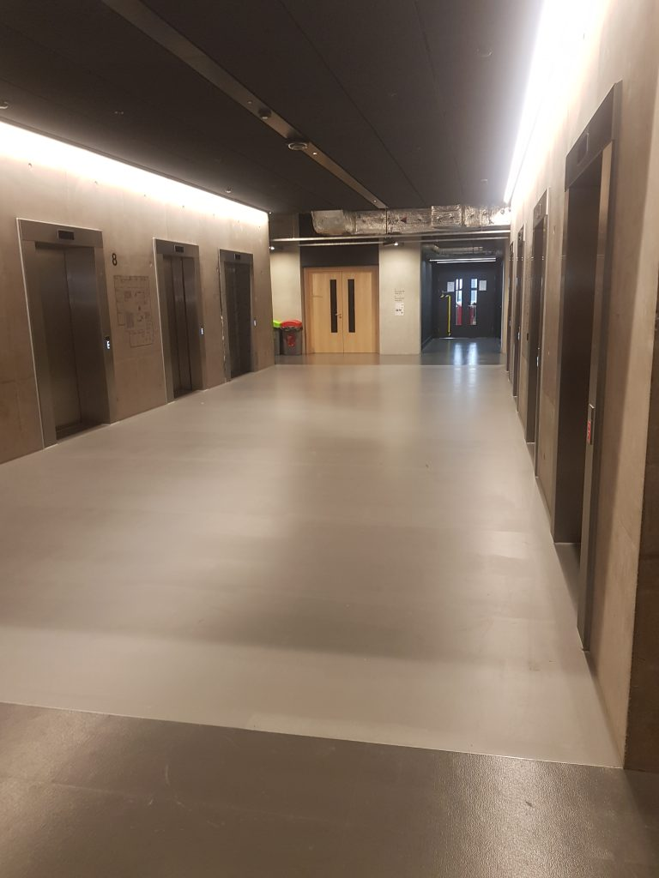

Masters, S (2023) *East Bank 8th Floor lifts November 2023*

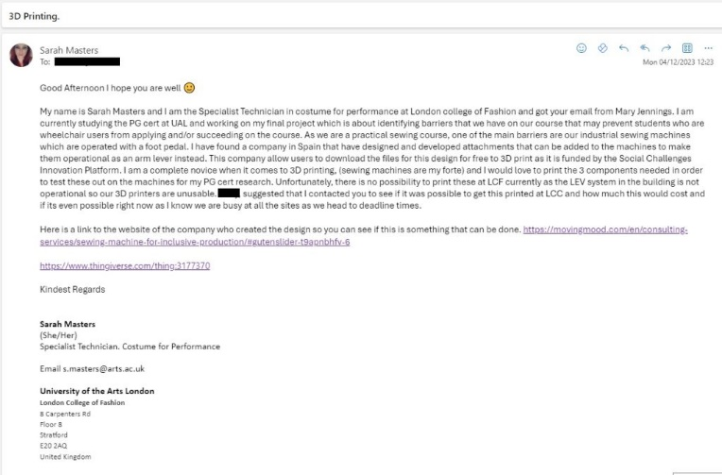

Masters, S (2023) Email to LCC

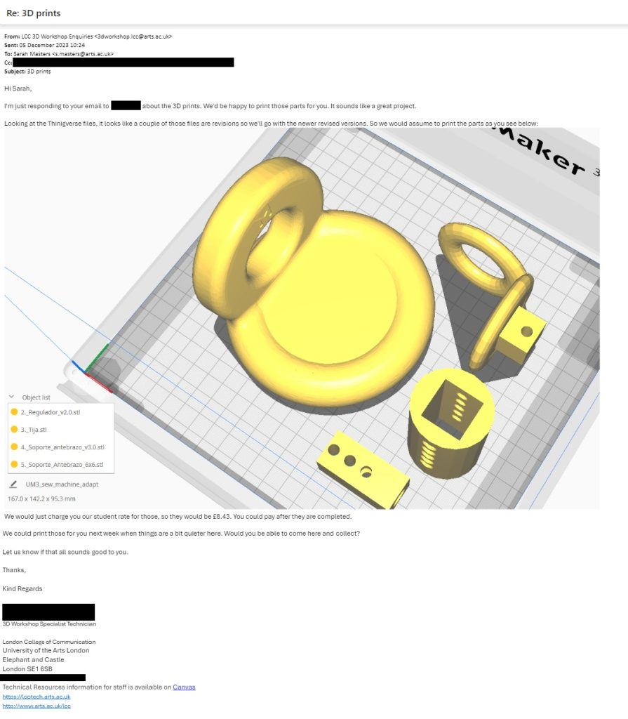

Masters, S (2023) Email reply from LCC

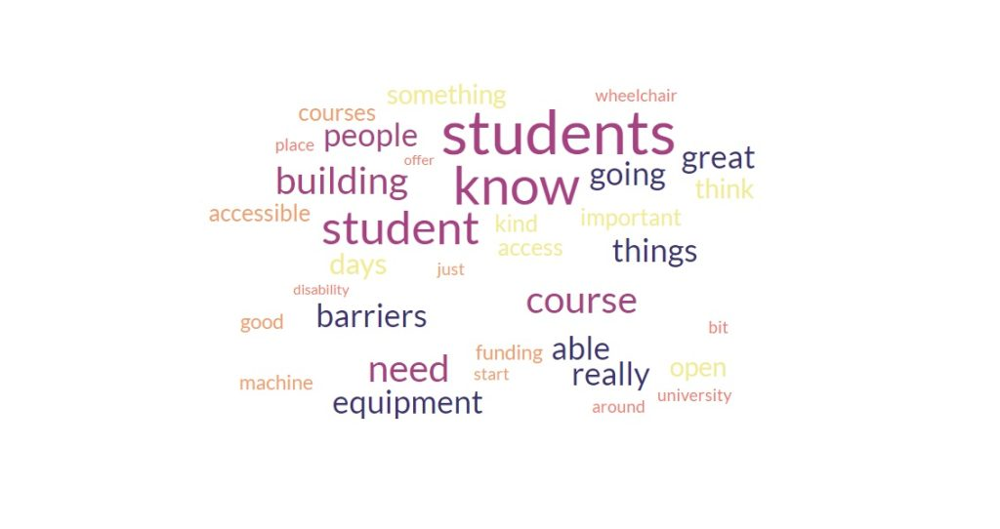

Masters, S (2023) Interview word cloud

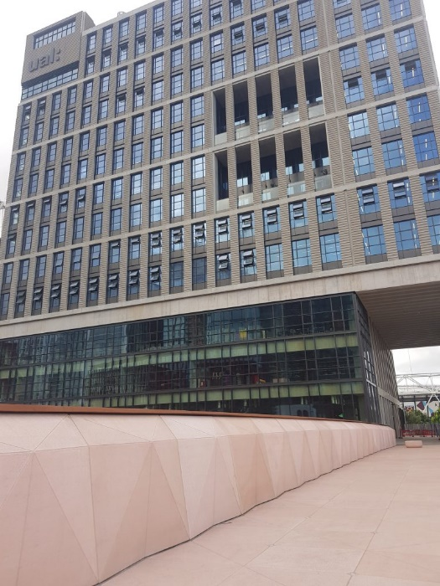

Masters, S (2023) *LCF East bank August 2023*

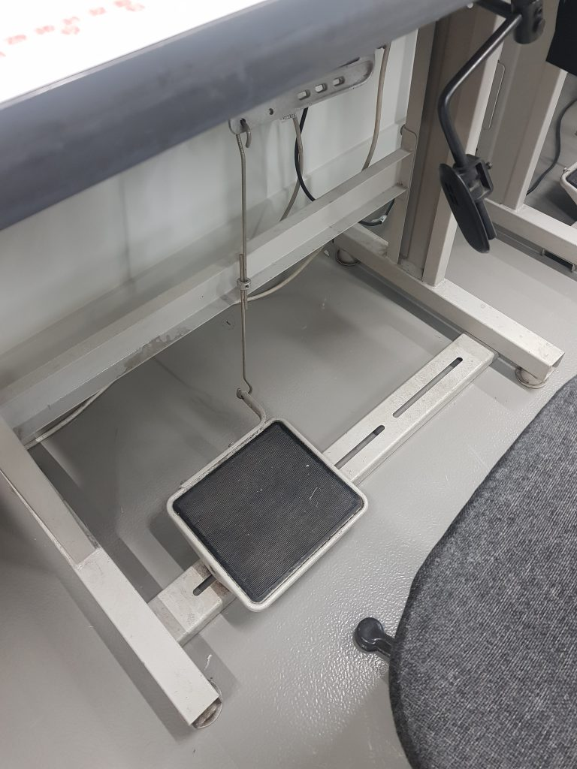

Masters, S (2023) Lockstitch machine

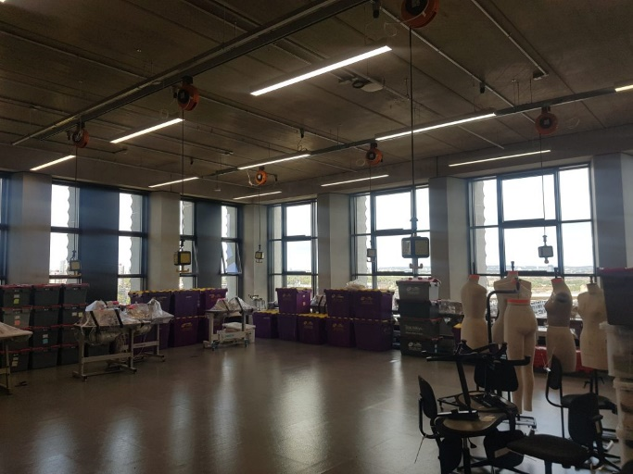

Masters, S (2023) *MA Costume 8th Floor August 2023*

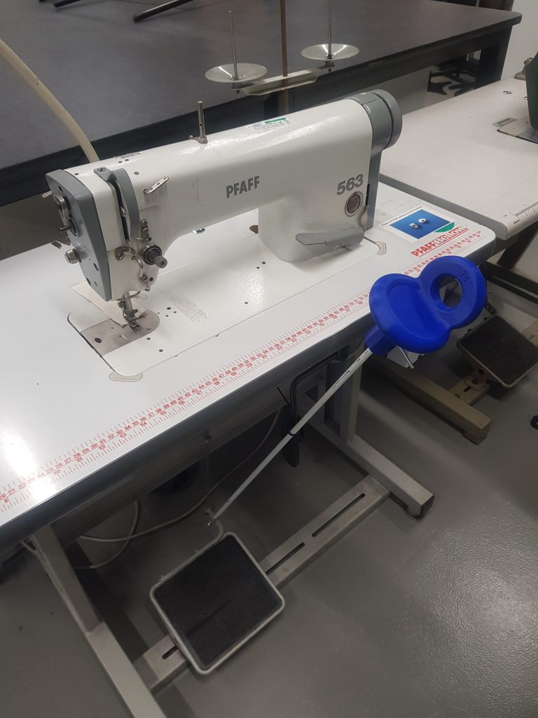

Masters, S (2024) Moving3Dmachine applied.

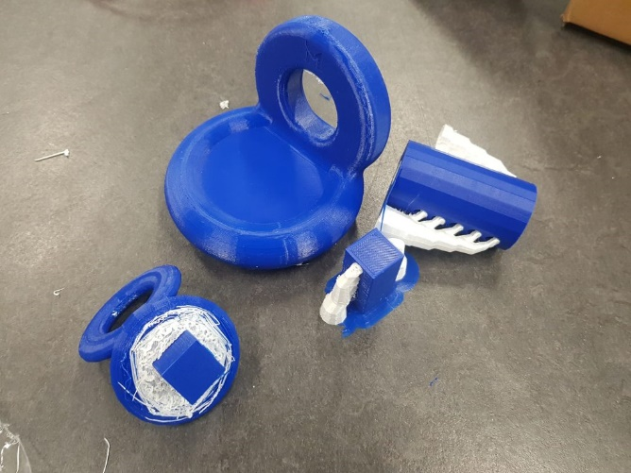

Masters, S (2023) Moving3Dmachine 3D print

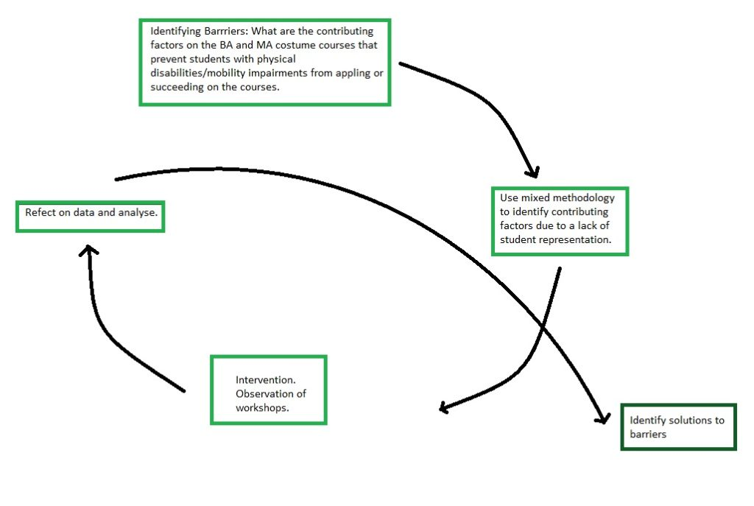

Masters, S (2023) My Action Research Cycle

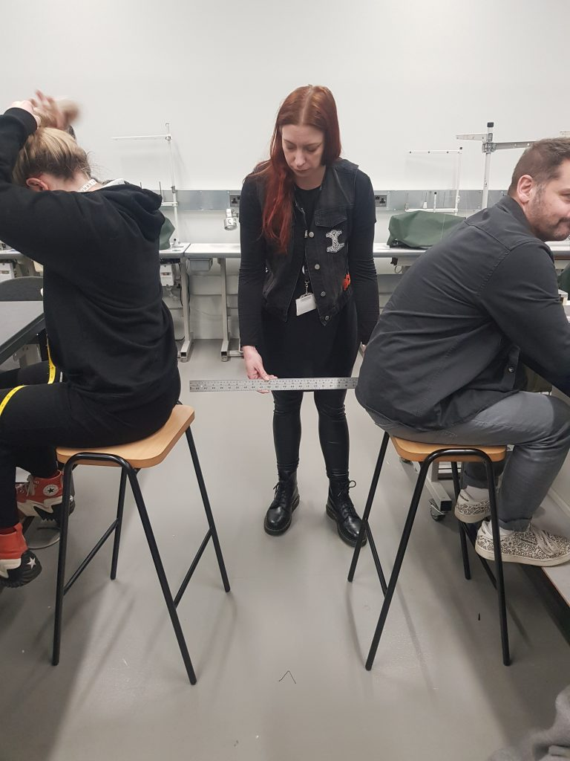

Masters, S. (2023) Occupied distance between stalls

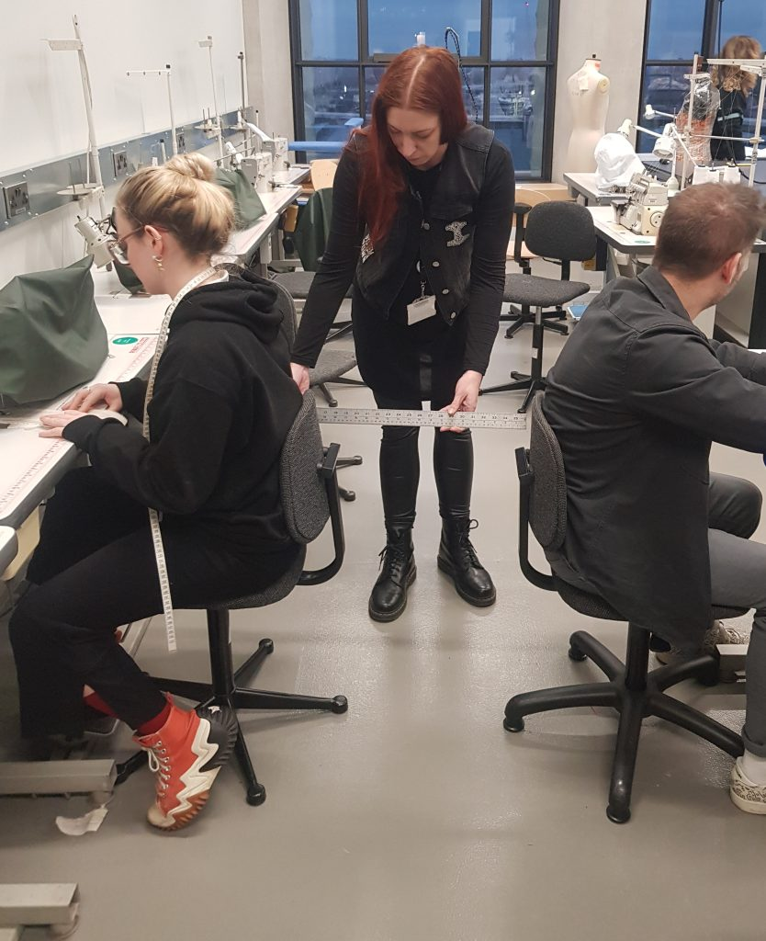

Masters, S. (2023) Occupied machines

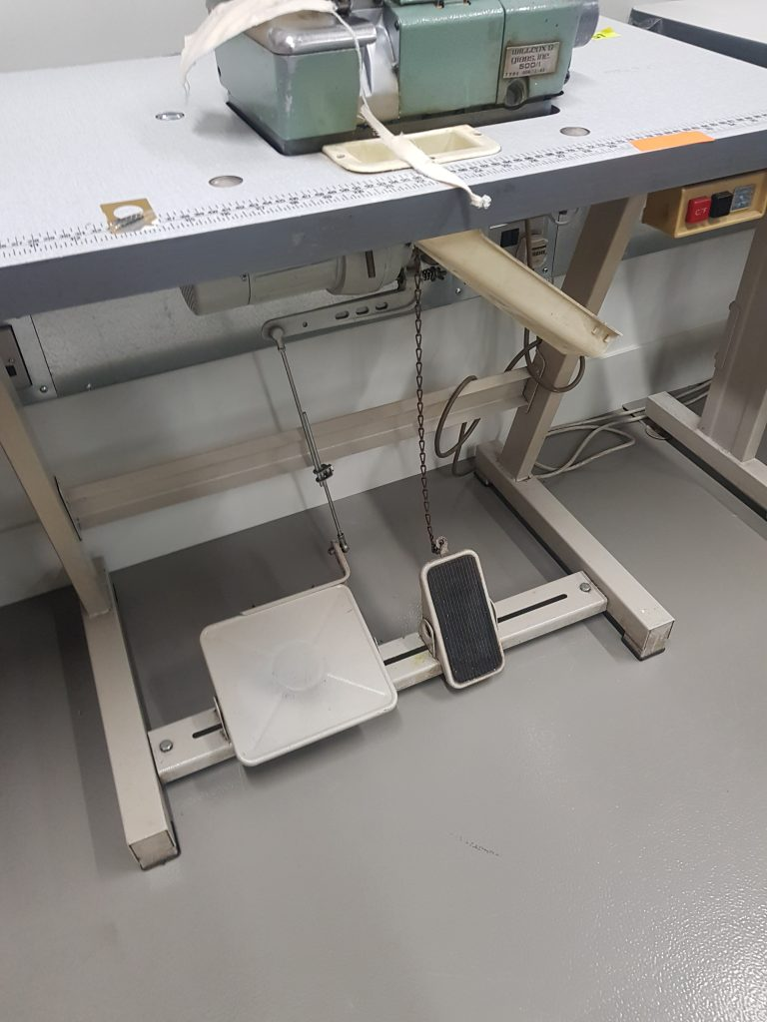

Masters, S. (2023) Overlock machine E823

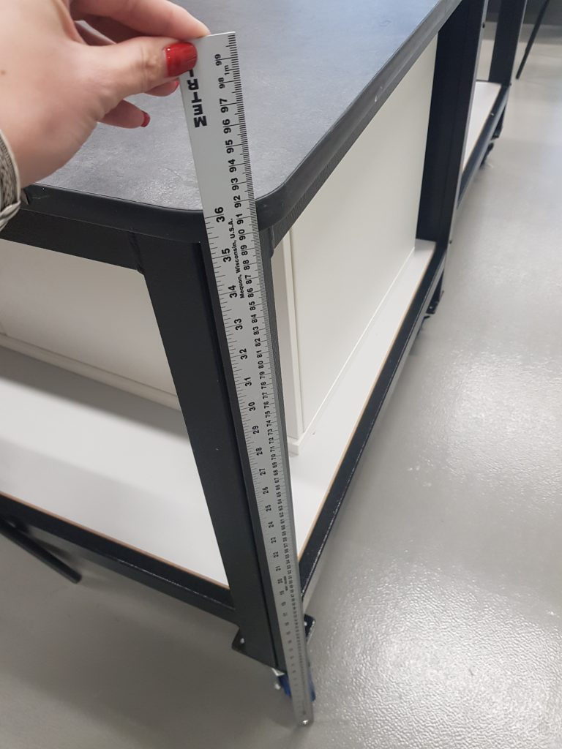

Masters, S. (2023) Pattern cutting table height EB823

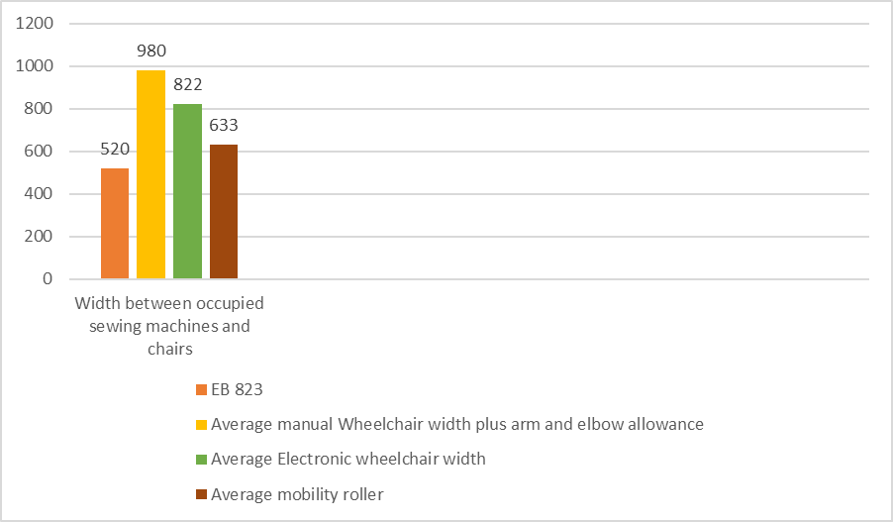

Masters, S (2023) *Path between occupied machines and chair.*

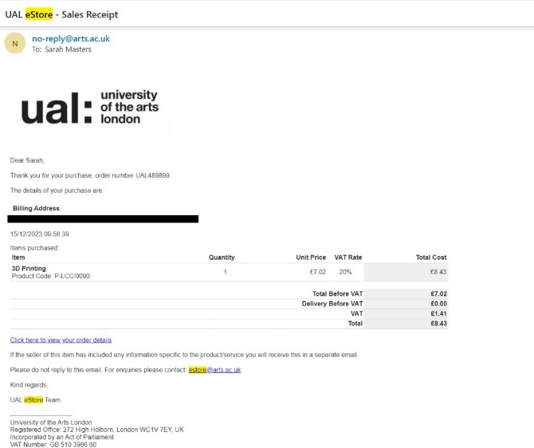

Masters, S (2023) Receipt of 3D print

Masters, S (2024) Video of machine in action

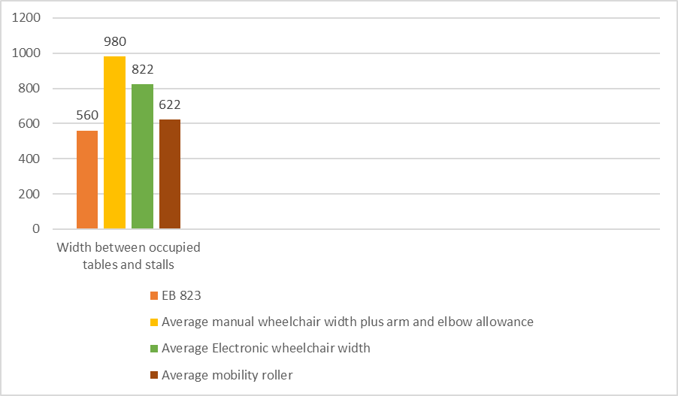

Masters, S (2023) *Width between occupied tables and stalls.*

Masters, S, (2024) Question two pie chart.

Masters, S (2024) Question six pie chart

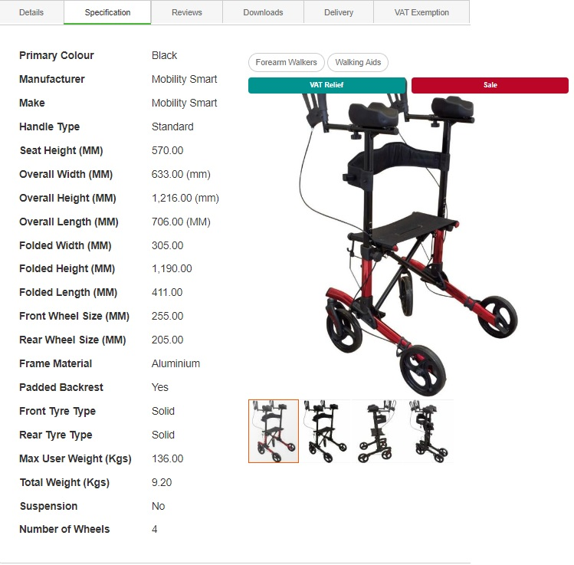

Mobility Smart (2023) The forearm rollator walker Available at https://www.mobilitysmart.co.uk/the-forearm-rollator-walker.html [Accessed] 25th November 2023.

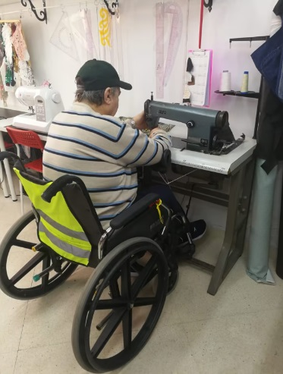

Moving Mood (2023) Sewing machines for inclusive production. Available at https://movingmood.com/en/consulting-services/sewing-machine-for-inclusive-production/#gutenslider-t9apnbhfv-6 Accessed 1st December 2023

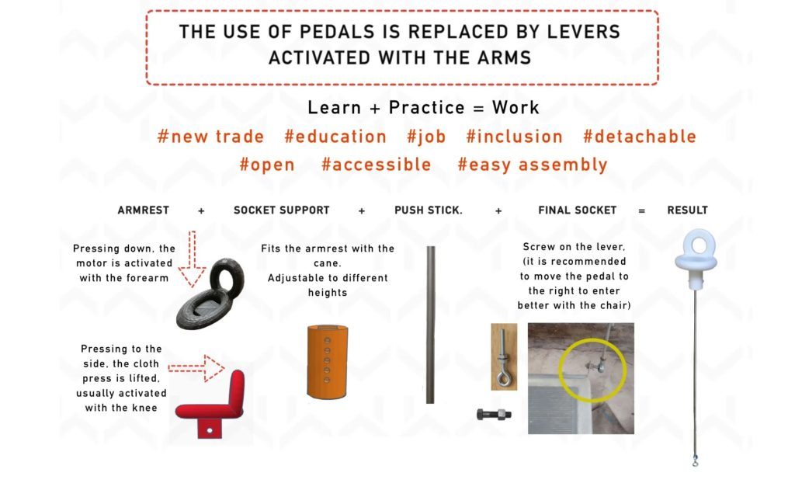

Moving Mood (2023) Sewing machines for inclusive production. Available at <https://movingmood.com/en/consulting-services/sewing-machine-for-inclusive-production/#gutenslider-t9apnbhfv-6> [Accessed] 16th December 2023

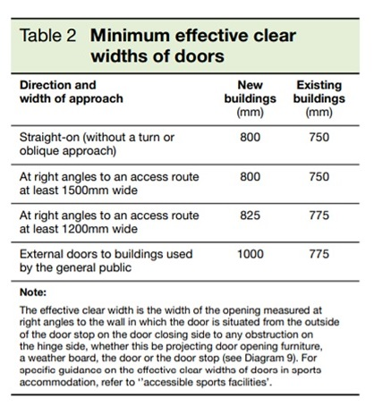

Rapid Ramp (2023) Table 2 minimum effective clear widths of doors. Rapid Ramp door widths. Available at [https://www.rapidramp.co.uk/product-news/the-correct-wheelchair-door-width Accessed 25th November 2023](https://www.rapidramp.co.uk/product-news/the-correct-wheelchair-door-width%20Accessed%2025th%20November%202023).

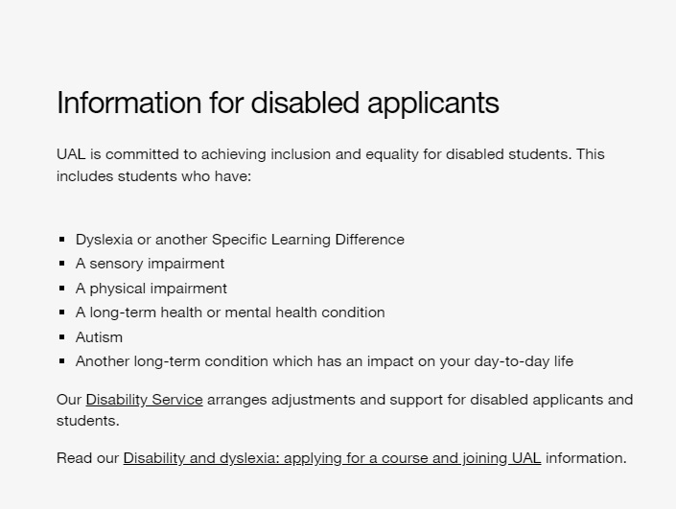

UAL (2023) BA (hons) Costume for Performance available at https://www.arts.ac.uk/subjects/performance-and-design-for-theatre-and-screen/undergraduate/ba-hons-costume-for-performance-lcf [Accessed] on 5th December.

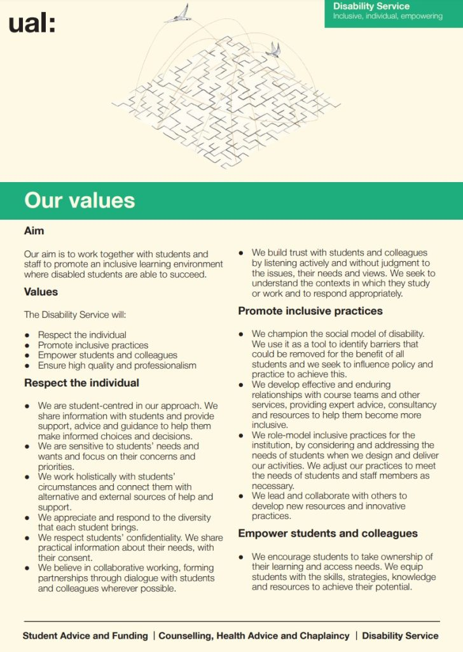

UAL (2023) *Disability services: Our Values*. Available at [https://www.arts.ac.uk/__data/assets/pdf_file/0029/28829/Disability-Service-Values-PDF-1080-KB.pdf Accessed 20th November 2023](https://www.arts.ac.uk/__data/assets/pdf_file/0029/28829/Disability-Service-Values-PDF-1080-KB.pdf%20Accessed%2020th%20November%202023)